Sprint 3 - Agility Design Document

December 3, 2020

Table of Contents
1. Executive Summary 3
1.1 Project Overview 3
1.2 Purpose and Scope of this Specification 3
2. Product/Service Description 3
2.1 Product Context 3
2.2 User Characteristics 3
2.3 Assumptions 3
2.4 Constraints 3
2.5 Dependencies 4
3. Requirements 4
3.1 Functional Requirements 5
3.2 Security 5
3.2.1 Protection 5
3.2.2 Authorization and Authentication 6
3.3 Portability 6
4. Requirements Confirmation/Stakeholder sign-off 6
5. System Design 6
5.1 Algorithm 6
5.2 System Flow 6
5.3 Software 6
5.4 Hardware 6
5.5 Test Plan 7
5.6 Task List/Gantt Chart 7
5.7 Staffing Plan 7

Executive Summary

Project Overview
The Sphero robot should accurately follow the obstacle course by first avoiding the three obstacles, then jumping over a ramp, and finally knocking over as many pins as possible.

Purpose and Scope of this Specification
In scope
- Audience: New Programmers
- Purpose: Learn block code and how to control what the robot does.
Out of Scope
The product specification is for the robot to follow the obstacle course by avoiding obstacles, jumping, and knocking over pins.

Product/Service Description

Product Context
This product can be used easily among children or people learning how to program. Yes, the product is independent and self-contained as it doesn’t need anything else to run and is it’s own program. Yes, this product interacts with a robot that is paired via Bluetooth. The program will send the block code you have inputted and sends it to the robot. The robot will then execute the code and the result is the robot changing led colors, turning, moving around, etc.

User Characteristics
- College Student:
  - Experience: Little to none
  - Technical expertise: Has worked in a computer repair shop
  - Other: Has been in a few programming classes in high school but isn’t very skilled in any specific language
- Teacher:
  - Expertise: Years of using this product or similar
  - Technical expertise: Has years of experience working with computers and different software
  - Other: Has many years of experience and knows the ins and outs of many languages
- Middle School Student:
  - Experience: None with any language
  - Technical Expertise: None
  - Other: Has a strong desire to learn how to build programs

Assumptions
- A Sphero compatible robot is needed to test the code.
- Must know very basic programming in order to use the product

Constraints
The biggest constraint is working with block code as it inherently doesn’t have the flexibility of text code, but the program does a good job with the variety of commands it gives. However, when it came to running tests everything went smoothly and there were no issues with software.

Dependencies
- Somebody in the group needs to know how to use the block code in order for anything to happen
- The robot needs the block code in order to function
- Measurements of the track are needed for the robot to follow or room HH208 needs to be reserved by a group member
- Bluetooth and WiFi are needed in order for the robot to function

Requirements

Functional Requirements
Req# | Requirement | Comments | Priority | Date Rvwd | SME Reviewed / Approved
AGIL_01 | Start in a square | Needs to be in position in order to have right alignment for the obstacle course. | 1 | 11/30/20 | 12/2/20
AGIL_02 | Avoid obstacle one | Must not hit an obstacle. | 1 | 11/30/20 | 12/2/20
AGIL_03 | Avoid obstacle two | Must not hit an obstacle. | 1 | 11/30/20 | 12/2/20
AGIL_04 | Avoid obstacle three | Must not hit an obstacle. | 1 | 11/30/20 | 12/2/20
AGIL_05 | Go over the ramp | Jump while retaining the right path on the obstacle course. | 1 | 11/30/20 | 12/2/20
AGIL_06 | Knock over as many pins as possible | Drive robot through path with enough momentum and accuracy to knock over as many pins as possible. | 1 | 11/30/20 | 12/2/20

Security

Protection
Actively saving your progress and making sure nobody but trusted group members have access to your account can help prevent tampering and destruction. Also, making sure you close the program whenever necessary is important, as leaving your computer open while away from work can invite people with malicious intent to disturb your work.

Authorization and Authentication
The authentication for this project is the use of a password that protects the code from anyone that does not have explicit access. Authorization for this project includes commits to the GitHub repository as adjustments can be made there to files if needed.

Portability
The code is shared on GitHub, which is open source. So, as long as the requirements are met, anyone can have the same outcome as long as the block code is written the same. As long as the operating system is recent and up to date, the Sphero program can be used.

Requirements Confirmation/Stakeholder sign-off
Meeting Date | Attendees (name and role) | Comments
11/30/2020 | Zoë (COO), Keven (PM), Maryam (PM) | We reviewed all the requirements and confirmed them together in a team meeting.

System Design

Algorithm
- Start in a square
- Avoid obstacle one
- Avoid obstacle two
- Avoid obstacle three
- Go over the ramp
- Knock over as many pins as possible

System Flow
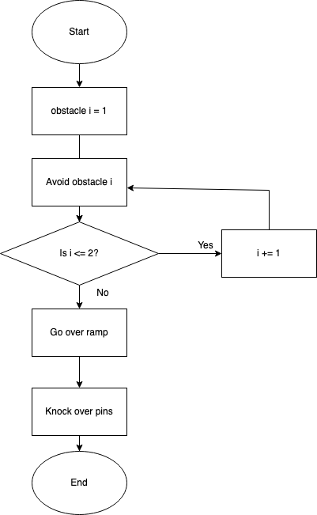

Software
Block code representing JavaScript code was manipulated using Sphero Edu software.
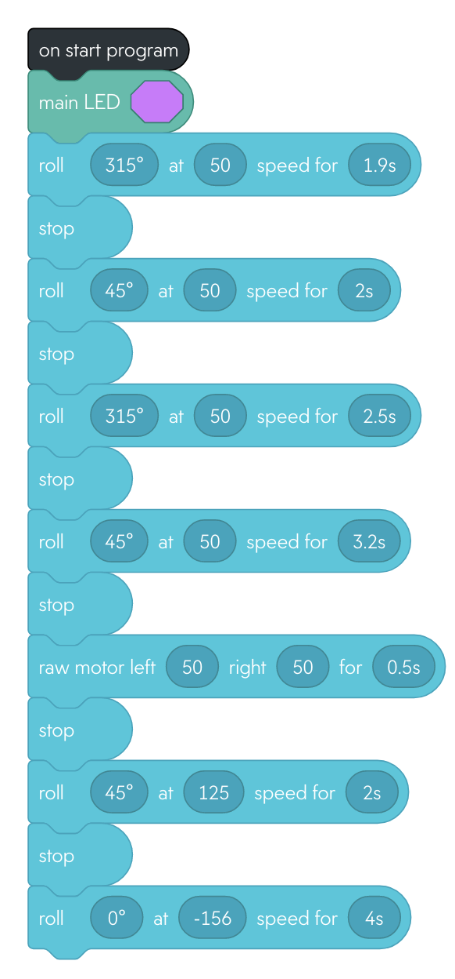
Sensor data was not available after turning in robot. The video of the robot shows the accuracy of the robot following the obstacle course. The obstacles, ramp, and pins were not in the room itself as expected, but it is clear in the video how the robot would perform if those items were present.

Hardware
The Sphero robot was used in testing. The version used was the SPRK+ and connected to a personal computer over Bluetooth in order to access the block code created by the COO.

Test Plan
Reason for Test Case | Test Date | Expected Output | Observed Output | Staff Name | Pass/Fail
First Test | 10/27/20 | Some errors, unknown. | A lot of errors to fix. | Maryam, Zoë, Keven | Pass
Fix Errors | 10/27/20 | Hoping to have measurements and jump fixed. | Did not go far enough in the beginning and at the end, it went way too fast. | Maryam, Zoë, Keven | Fail
Fix measurements and jump point | 10/27/20 | Hoping for the robot to have correct measurements and jump at correct point. | Measurements were a little better this time but towards the end it did not end up going far enough. | Maryam, Zoë, Keven | Fail
Steadier aim | 10/27/20 | Trying to reset the aim and make it steadier. | Was better but we will try to make one part longer to follow the course more accurately and to fix the aiming. | Maryam, Zoë, Keven | Fail
More accurate, fix aim | 10/27/20 | Trying to make measurements accurate and fix aim. | Followed the obstacle but jumped too early so we will try to fix that. | Maryam, Zoë, Keven | Fail
Fix jump and measurements | 10/27/20 | Try to fix jump and some of the measurements and try to make it not come to us at the end. | Measurements were better but still problems with jump. | Maryam, Zoë, Keven | Fail
Slow jump | 10/27/20 | Slowed down the jump speed to see if that would help. | Did not jump but it was much more stable than when the jump speed was set higher. | Maryam, Zoë, Keven | Fail
Fix degree of movement | 10/28/20 | Got rid of the 45 heading after the jump to see if that would help. | Did not end up jumping, lags a little bit before it comes back. | Maryam, Zoë, Keven | Fail
Speed up movement after jump | 10/28/20 | Added speed to the movement after jump. | Result was a little better, but it still did not seem to jump. | Maryam, Zoë, Keven | Fail
Lengthen time of movement | 10/28/20 | Changed length of time so it was moving for a longer period of time. | A much better result and it ended up jumping before the square but picked up speed after and then started to speed up towards the end of the course. | Maryam, Zoë, Keven | Fail
Fix timing for obstacles and decrease speed after jump | 10/28/20 | Changed timing for the beginning of the course and then after jump decreased the speed. | The timing was a little off, but the results were much better than what we had before. | Maryam, Zoë, Keven | Fail
Fix obstacle measurements | 10/28/20 | Make the first line of the course longer to see if that helps the other problems. | It helped the first part, but the second part was still short. | Maryam, Zoë, Keven | Fail
Fix measurements | 10/28/20 | Make the second part longer and then the part after the jump longer. | This helped much more even though there were still problems with the second one. The jump was on time and it helped, and it hit the pins in the end too. | Maryam, Zoë, Keven | Fail
Fix measurements | 10/28/20 | Try and make the second part a little longer to try and avoid the obstacle. | The timing was close this time, but the only problem was that it did not hit the pins at the end. | Maryam, Zoë, Keven | Fail
Finalize measurements for best accuracy | 10/28/20 | We shortened the time after the jump to see if that would help it follow the course. | Product is complete. | Maryam, Zoë, Keven | Pass

Task List/Gantt Chart
Full Gantt Chart on GitHub: here.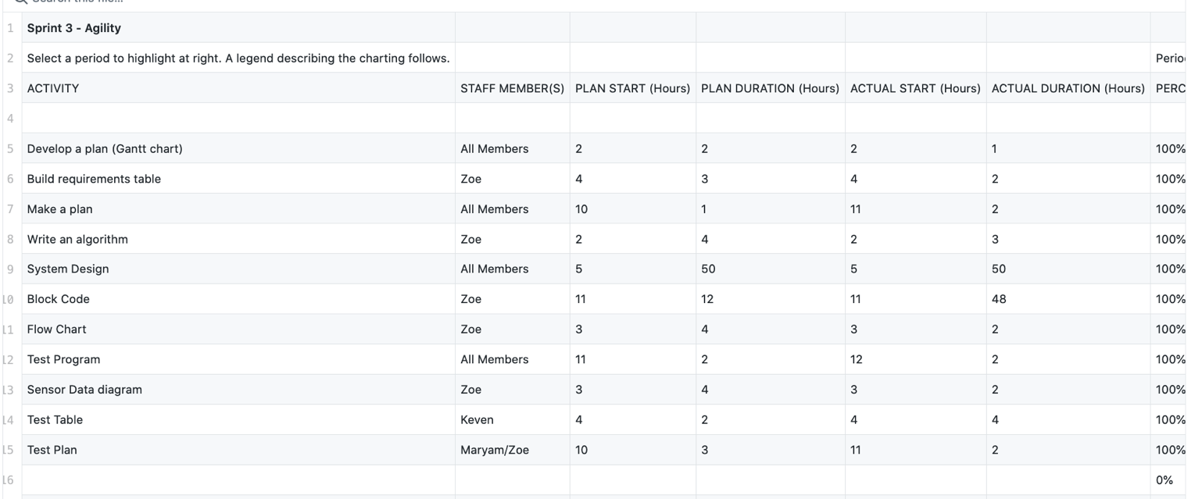
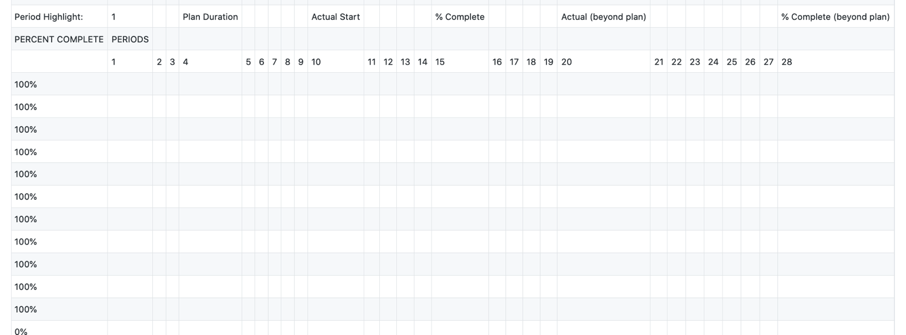

Staffing Plan
Name | Role | Responsibility | Reports To
Zoë Klapman | COO, software developer | Oversee operations, program/test robot, sections 3.1 and 5 of system design document. | (CEO) Professor Eckert
Keven Kevelier | PM | Monitor task list/gantt chart, sections 2-4 system design document. | (COO) Zoë Klapman
Maryam Kakar | PM | Monitor task list/gantt chart, section 1 and 5.5 of system design document. | (COO) Zoë Klapman

